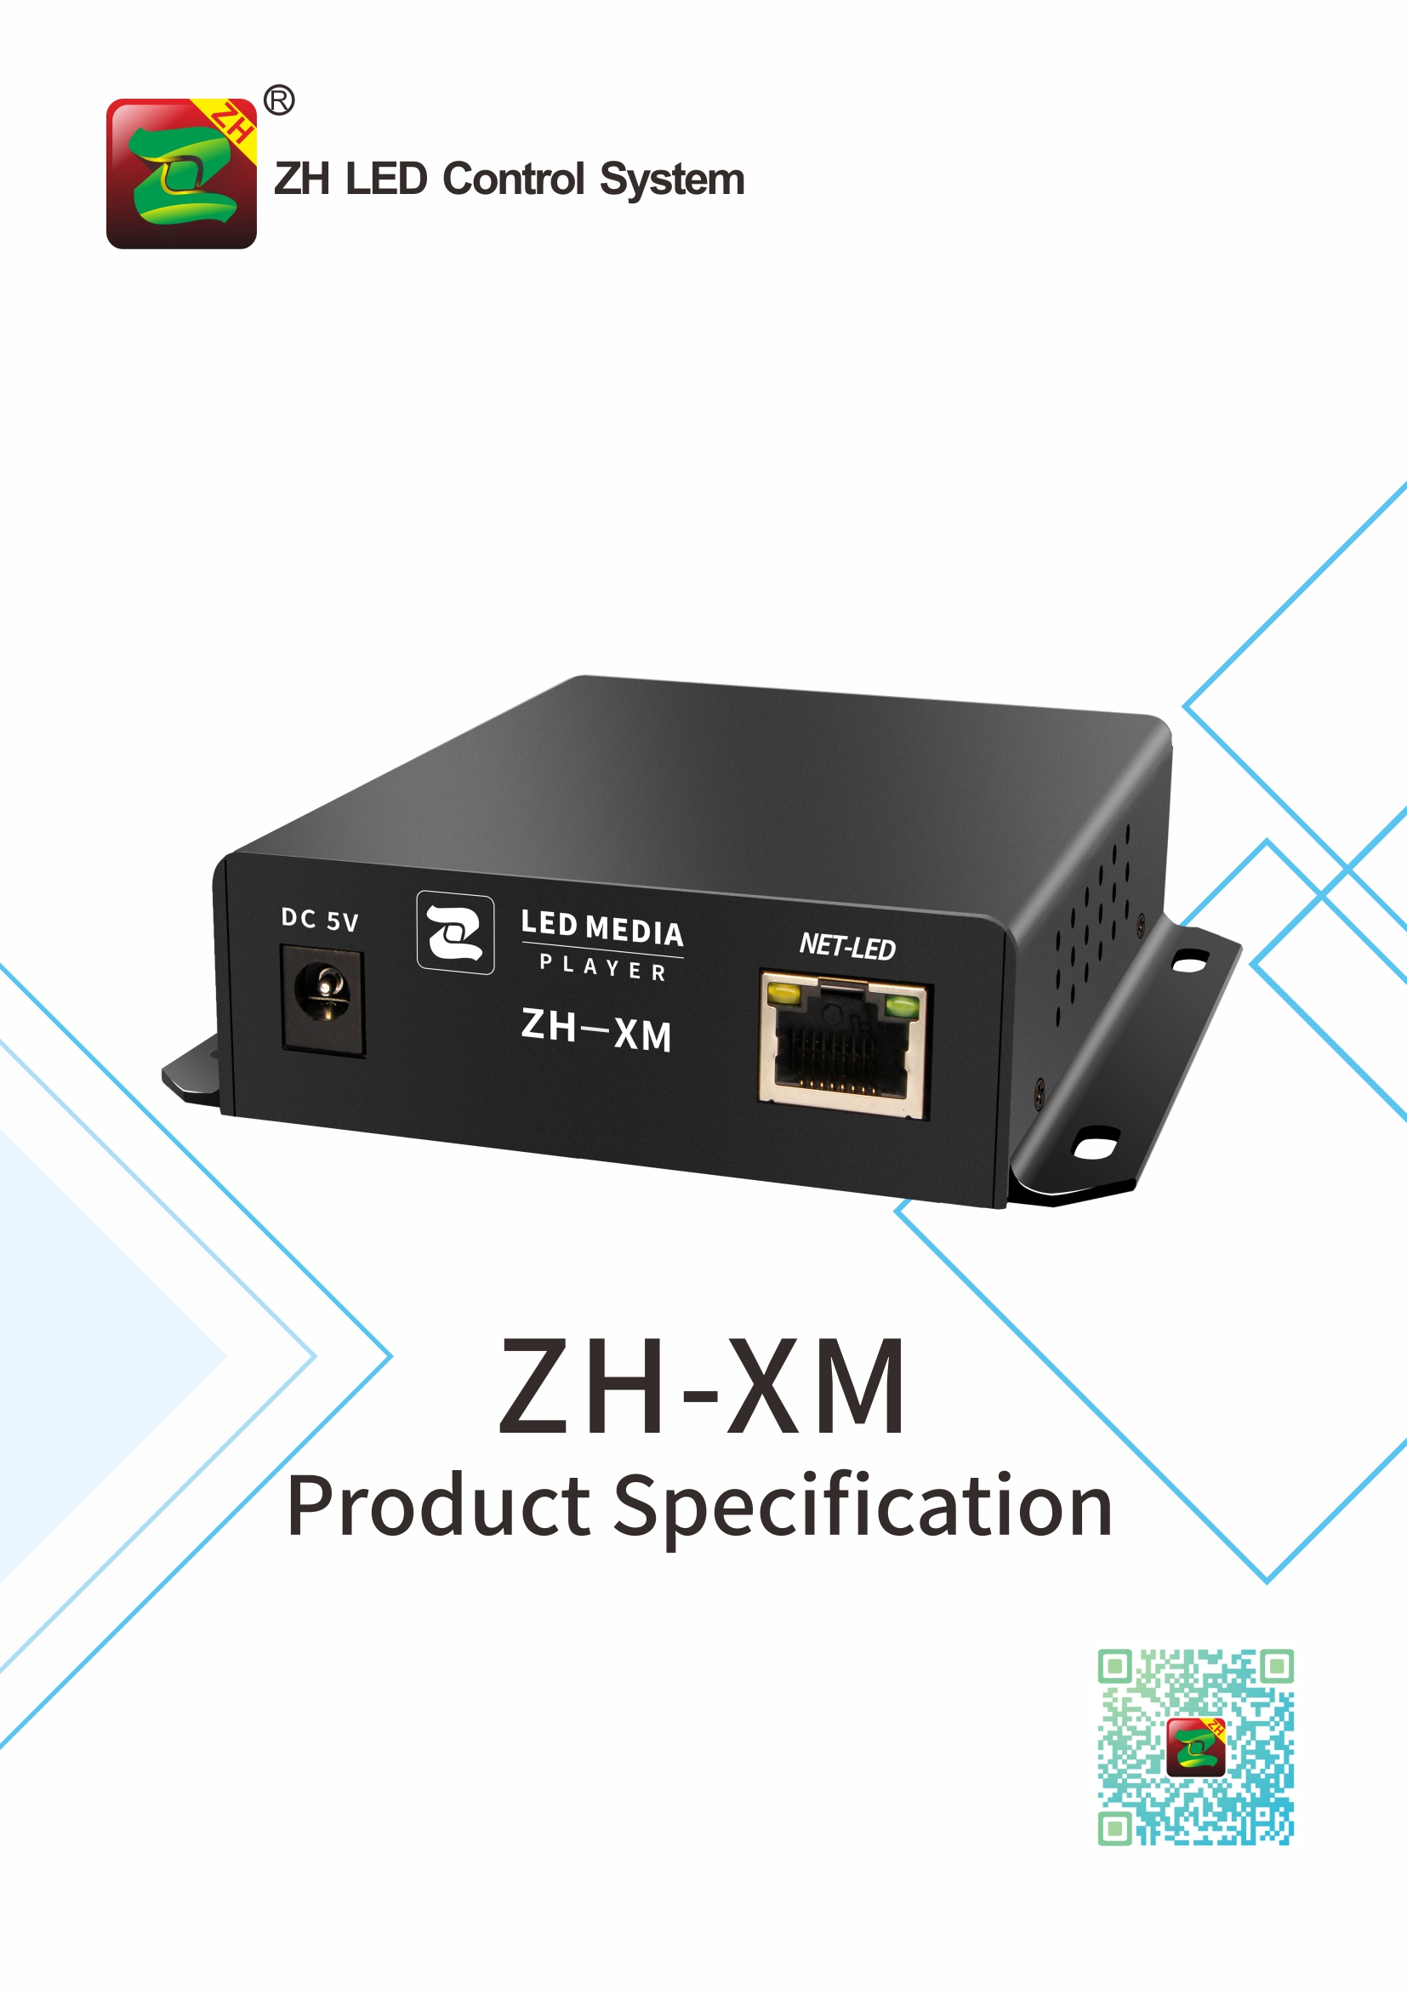

ZH-XM Specification
I. Function Introduction:
ZH-Xm belongs to full color series LED player, its functions are as follows:

- Adopt the same refresh technology as synchronous control system;
- Support cascading receiving card,support any size screen.
- Support mobile APP (Android + iPhone) to send program;
- Support remote management about Wi-Fi hot-spot (AP mode) and Internet (STA mode);
- Provide SDK;
- Support HD video hard decoding;
- Supports audio output, 3.5mm standard audio output interface;
- Support USB to play video and pictures directly;
- Support regularly adjust brightness, and play program regularly;
- Support UDP network communication protocol;
- Support DHCP to obtain IP address automatically;
- Support emergency information insertion;
- Support weather forecast.
- Support one-button testing full screen;
- Support manual switch, timing switch.

II. Basic Function Parameters

System Parameters
CPU | 4-cores CPU
Operation System | Android 9.0
System Storage | 4G（1.2 G available）
Control Area | Loading Points: 650.000 points  Maximum Width: 1920，Maximum Height: 1344
Support Resolution  (Width*Height) | 480*1344，512*1280，576*1080，640*1024，680*940，768*832，800*800，896*728，960*680，1024*640，1040*600，1120*576，1152*544，1280*512，1352*468，1440*448，1536*410，1600*400，1760*368，1920*340
Receiving card | All series ZH receiving card
Device Port
Synchronous input interface and quantity | Not support synchronous
Asynchronous input interface and quantity | Gigabit network*1,USB*1,WiFi*1
Output port and quantity | Gigabit network*1,Audio*1
Media playback formats
program, window | Multi-program sequence, timing and other playback methods; arbitrary partition and overlay playback of windows
Video formats | AVI,F4V,WMV,MPG, RM/RMVB,MOV,VOB,MP4,FLV,TS,MKV and other common video formats;
Picture formats | BMP、JPG、PNG、GIF and so on
Audio formats | MPEG(MP3)、AAC and so on
Text document | Support software to edit single-line, multi-line, colorful text; support TXT documents import; support word, Excel, PPT, etc. of 2007 or later versions of office import
Other function | Support clock, watch face, timing, weather forecast (commercial grade), streaming media, etc.
Management and control
Software | PC：LEDPlayerV5；APP：LED Mobile Color
Program update communication | U disk export, plug and play; self-adaptive 100M/1000M network port direct connection or access to LAN to send; WiFi AP mode or STA mode control
FPGA file | Built-in many brand module FPGA file, can quickly debug the display
Brightness setting | Screen brightness can be set according to time
Remote controller | Play volume, signal, material, etc. can be controlled through the software remote control function
cluster mode | Support local server clusters
Safety
Local | Support local send password setting

III. Input/Output Port Arrangement and Definition

Hardware Introduction:

The Front Panel

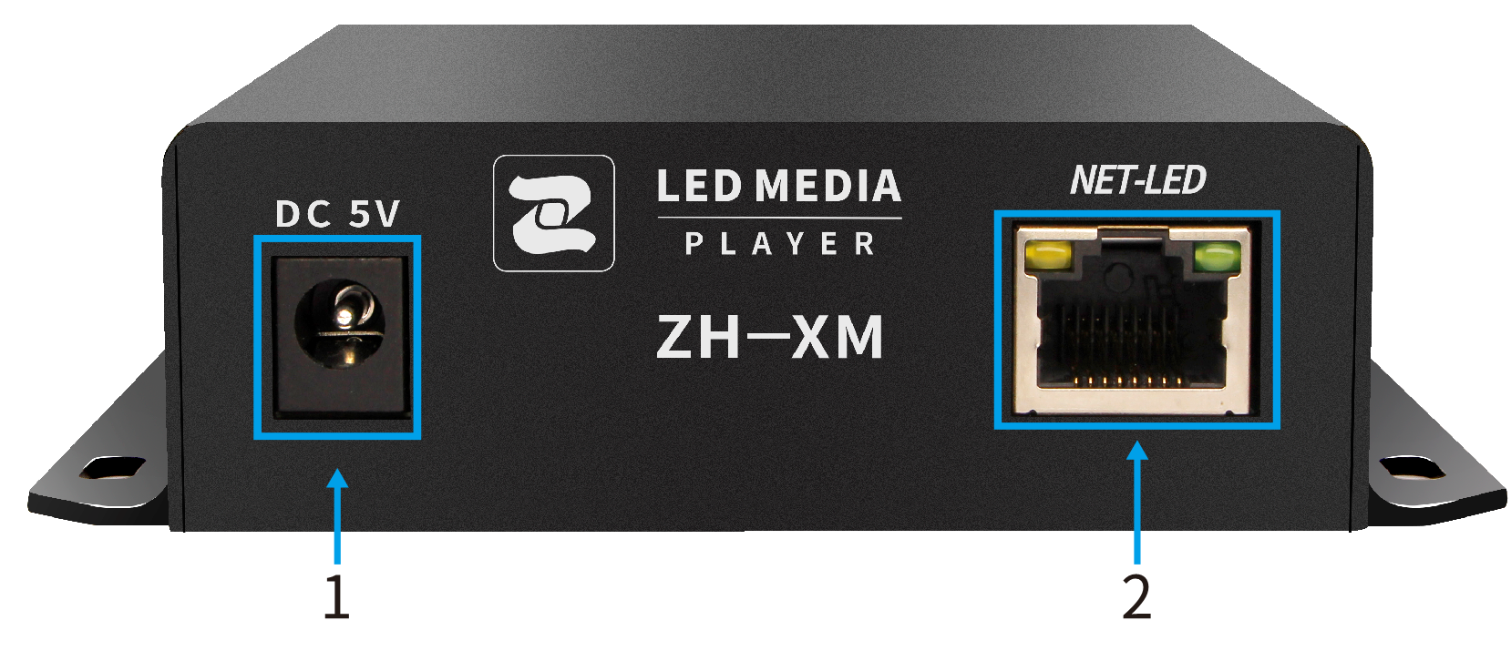

The Back Panel

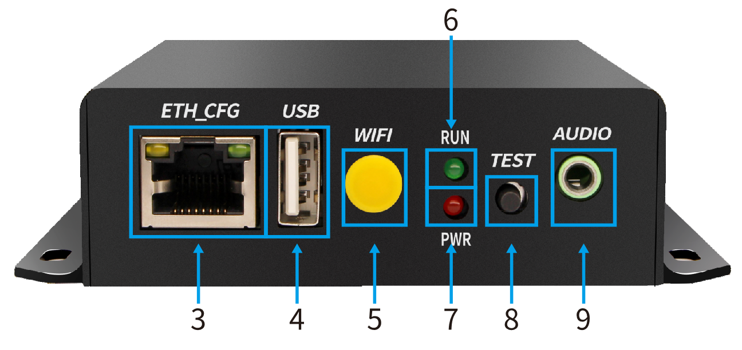

NO. | Name | Function | Note
1 | PWR | DC 5V port | Power supply
2 | NET-LED | LAN port, connect with receiving card
3 | ETH_CFG | PC port. Link with computer, set parameter, send content
4 | USB | USB port, Update hardware
5 | WIF | WiFi antenna port | Link with WiFi antenna
6 | PWR/RUN | Power indicator | Red light always on
6 | PWR/RUN | Operation indicator | Green light flashing regularly
7 | TEST | Test button, check version, test screen | 13 kinds of test mode
8 | AUDIO | Audio output port | Connect external active amplifier

Working Condition:

Rated voltage (V) | 5.0 | Maximum | 6 | Minimum | 4
Rated current (A) | 1.5 | Maximum | 3.2 | Minimum | 0.8A
Rated power consumption (W) | 7.5 | Maximum | 16 | Minimum | 4
Extreme temperature(°C) |  | Maximum | 80 | Minimum | -40
Working environment temperature (°C) |  | Maximum | 80 | Minimum | -40
Working environment humidity (%) |  | Maximum | 95 | Minimum | 0

IV. Hardware Diagram:

